**Name - R.Rishika**

**Btech - Final year (IT)**

**AI related course work/project/experience**

# Mile Stone 1 Dataset Collection and Preparation

## Week 1 day 1

**FINDINGS:**

From my review i understood that we need three datasets

1.Segmentation dataset - ruins,vegetation,soil

2.Object detection dataset - artifacts

3.Erosion prediction dataset - terrains

In first week, we will download images from Google Earth Pro then zoom into an archaeological area, ruin location, desert region, old structures etc. Then Annotate those images manually using Labelbox.

—> Sentinel-2 gives free high quality earth images that we will use for segmentation and erosion prediction.

[Harmonized Sentinel-2 MSI: MultiSpectral Instrument, Level-2A (SR) | Earth Engine Data Catalog | Google for Developers](https://developers.google.com/earth-engine/datasets/catalog/COPERNICUS_S2_SR_HARMONIZED?hl=en#colab-python)

## Week 1 day 2

Learnings:

-> Vegetation means all plants covered areas.This includes Forests, Trees, Grasslands.

-> Ruins means broken, damaged or old structures from the past. This includes Old temples, Ancient buildings, broken stone walls.

->Terrain means the natural shape of the land. This includes Hills, Valleys, Rocks.

**Downloaded Google Earth Pro**

Downloaded Google Earth Pro from google in my laptop

**Steps:**

[1. On](http://1.on) the top left side in search bar select any place in India.

2. It will redirect to that place in map.

3. Now select the resolution to its maximum for better quality.

4. Click on file->save->save image.

5. Created a separate folder for the project:

A folder named “Annotating the image” was created under “My Places” to store all annotations in an organized manner.

6. Added point annotation for Ruins:

A placemark named “**Ruin A**” was created and placed at the exact location on the satellite map.

7. Added polygon annotation for Vegetation:

A polygon named “**Vegetation**” was drawn by clicking multiple points around the ground area. The polygon was filled with green color to clearly highlight vegetation.

8. Adjusted style settings:

->Line width was set to **2.0**

->Color was set to **green**

->Fill opacity was set to **50%**

9.Saved the polygon inside the folder

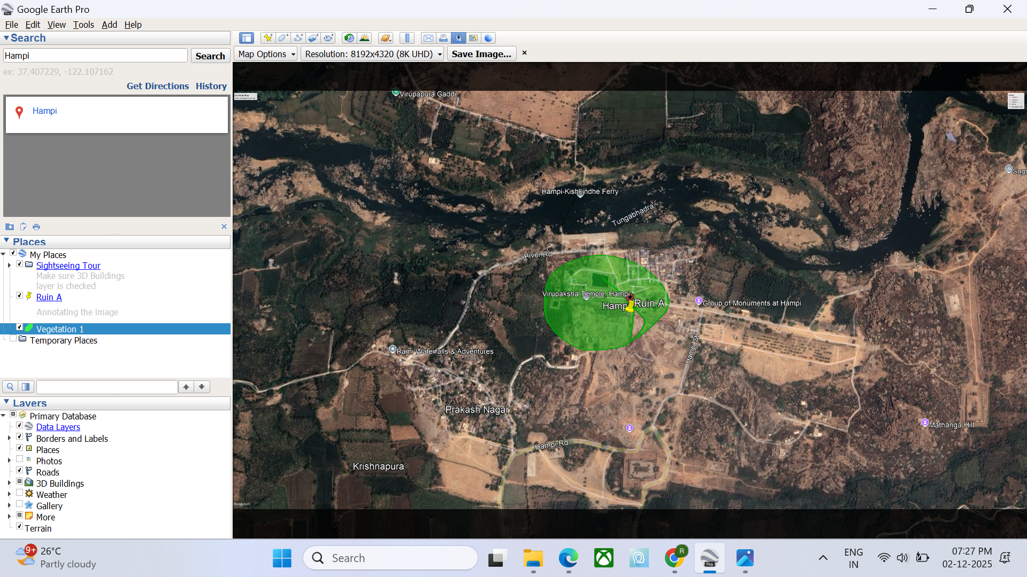

## 

## Week 1 day 3

**Understood How to Identify Features in Satellite Images**

Learned how to visually identify:

Vegetation – dark green areas (trees, plants)

Soil / Land – brown/yellow natural ground

Ruins – rectangular/square shapes, stone structures, old temple layouts

Water – rivers, lakes, dark blue/black patches

**Learned Correct Annotation Method**

* One image should contain all classes annotated together.
* Not separate images for each category.
* Avoid coloring the entire area with one color.
* Each region must be manually annotated separately.

Use one fixed color for each class:

Vegetation → Green

Soil/Terrain → Brown

Ruins → Yellow

Water → Blue

**1.Vegetation:**

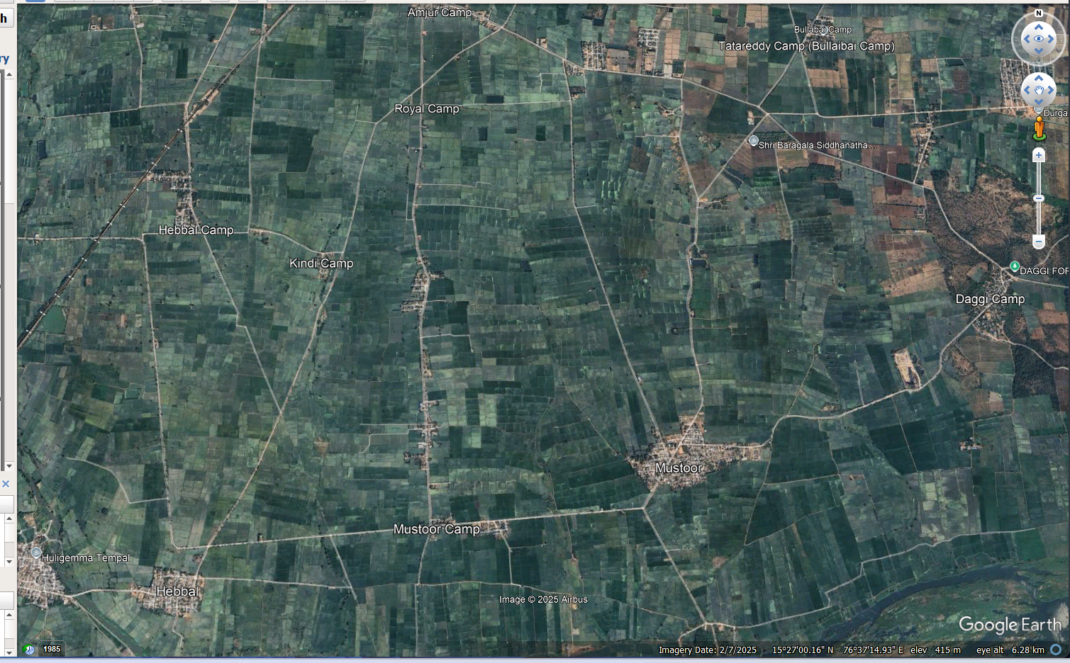

**2. Ruins:**

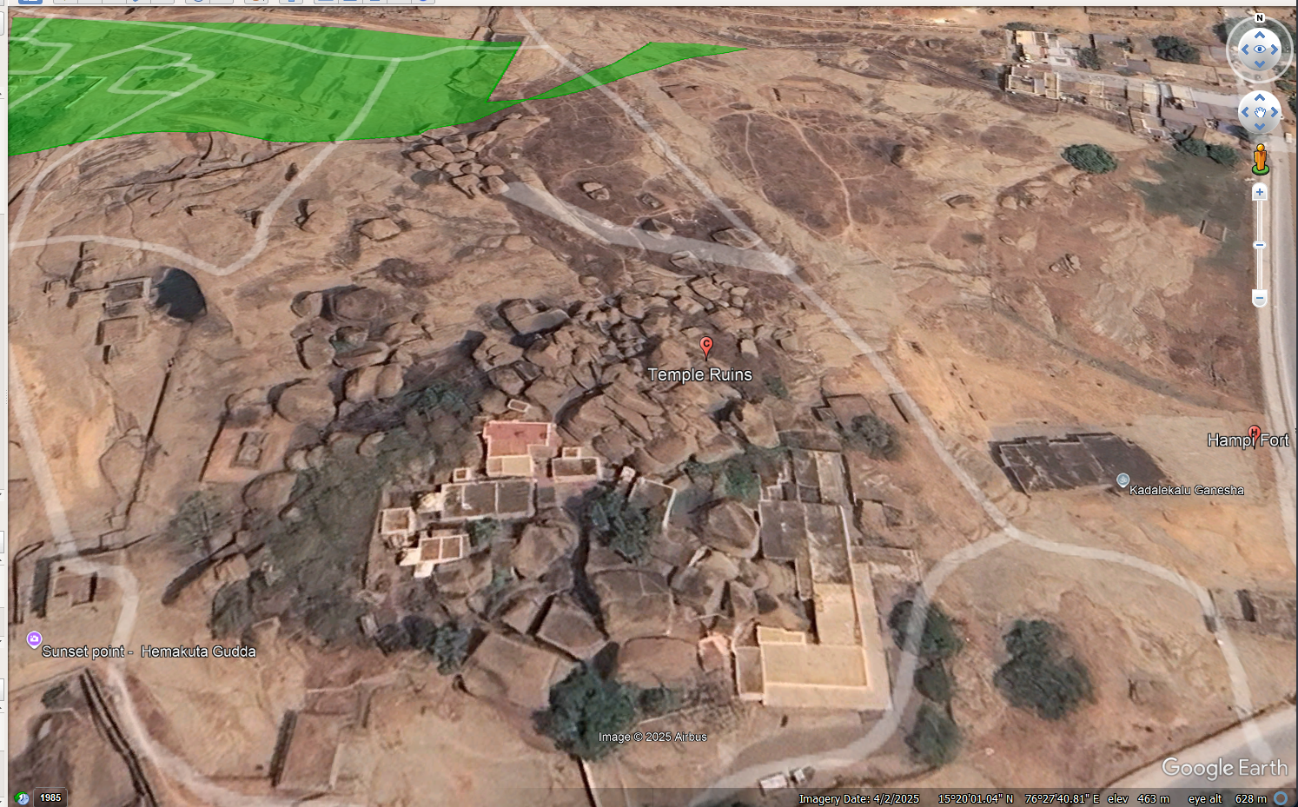

**3.Soil:**

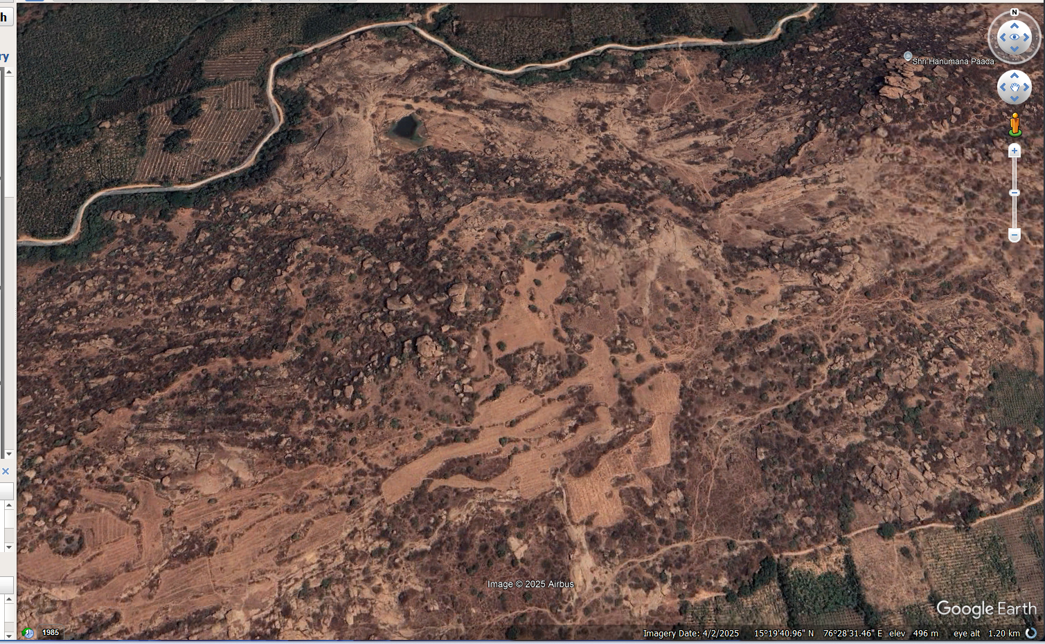

## Week 1 day 4

## **1. Data Collection & Annotation**

### **A. Image Collection**

## Capture screenshots from Google Earth (same zoom level).

## Avoid tilt; use high resolution.

### **B. Annotations Needed**

## **Ruins mask** → damaged structures.

## **Vegetation mask** → green areas.

## Can use **two separate masks** or **one multi-class mask** (0=background, 1=ruins, 2=vegetation)

### **Tools**

## LabelMe

## CVAT

## Labelbox

## SuperAnnotate

## 

## **2. Preprocessing**

## Resize all images & masks → **512×512**.

## Normalize images → img/255.

## 

## **3. How Segmentation Masks Work**

## Input → RGB image (512×512×3)

## Output → Mask (512×512×1) with pixel-wise class labels.

## 

## 

## **4. U-Net Overview**

## U-shaped encoder–decoder architecture.

## Uses skip connections for fine details.

## Works well with small datasets and limited GPU.

## Loss functions:

## Binary Cross-Entropy (2 classes)

## Categorical Cross-Entropy (multi-class)

## Dice Loss (overlap accuracy)

## 

## **5. DeepLabV3+ Overview**

## More advanced model for accurate segmentation.

## Uses atrous convolutions + ASPP module.

## Best for **large** or **complex** datasets.

## **When to choose:**

## Small dataset → **U-Net**

## High-quality output → **DeepLabV3+**

## 

## **6. Training Workflow**

## Organize data → images/ and masks/

## Resize & normalize images

## One-hot encode masks

## Choose model (start with U-Net)

## Train for 20–50 epochs

## Evaluate using IoU & Dice Score

## 

## **7. Model Output**

## Model outputs probability maps for each pixel (e.g., [0.02, 0.80, 0.18]).

## Highest value → predicted class.

## Convert predictions to colored masks for visualization.

## Week 2 day 1

**How U-Net Works**

**1. Inputs to U-Net:**

A photo (example: satellite image)

A colored version of the same photo (the mask)

**2. What the model learns**

U-Net learns which part of the image belongs to which color or class.

For example:

This region should be green

This region should be blue

This region should be brown

After seeing many examples, it can label new images by itself.

**3. Processing the input image**

U-Net first takes the input image and checks colors, shapes, edges, etc.

**4. Encoding (making the image smaller)**

The image is compressed so the model can understand important features.

This part is the left side of the U-shape.

**5. Decoding (making the image bigger again)**

The compressed image is expanded back to the original size.

This is the right side of the U-shape.

**6. Using the mask for learning**

You give U-Net the labeled mask

Water → label 1

Soil → label 2

Vegetation → label 3

U-Net compares the image and the mask and learns the correct labels.

**7. Prediction**

After training, when you give a new image, U-Net automatically produces the segmentation mask.

## Week 2 day 2

**YOLO for Artifact Segmentation**

**YOLO (You Only Look Once):**

YOLO is a deep learning model that detects objects quickly in an image.

**What is artifact segmentation?**

Artifact: Unwanted object in an image (e.g., dust, scratches, noise, blur, patches, spots).

Artifact segmentation: Finding and marking only the unwanted parts in an image.

**How YOLO works:**

1. YOLO divides the image into small squares.

2. Each square checks: Is there an object here?

It looks for color, shape, edge, patterns.

3. If an object is found → YOLO draws a box or mask around it.

4. YOLO identifies what the object is.

5. It does all of this in a single pass.

**LabelBox**

→ Go to [labelBox.com](http://labelbox.com) and signup

→ click on create project and give project name

→ click on ontology and click on add object

→ give names like ruins and select proper Tool according to that object

→ do same for vegetation.

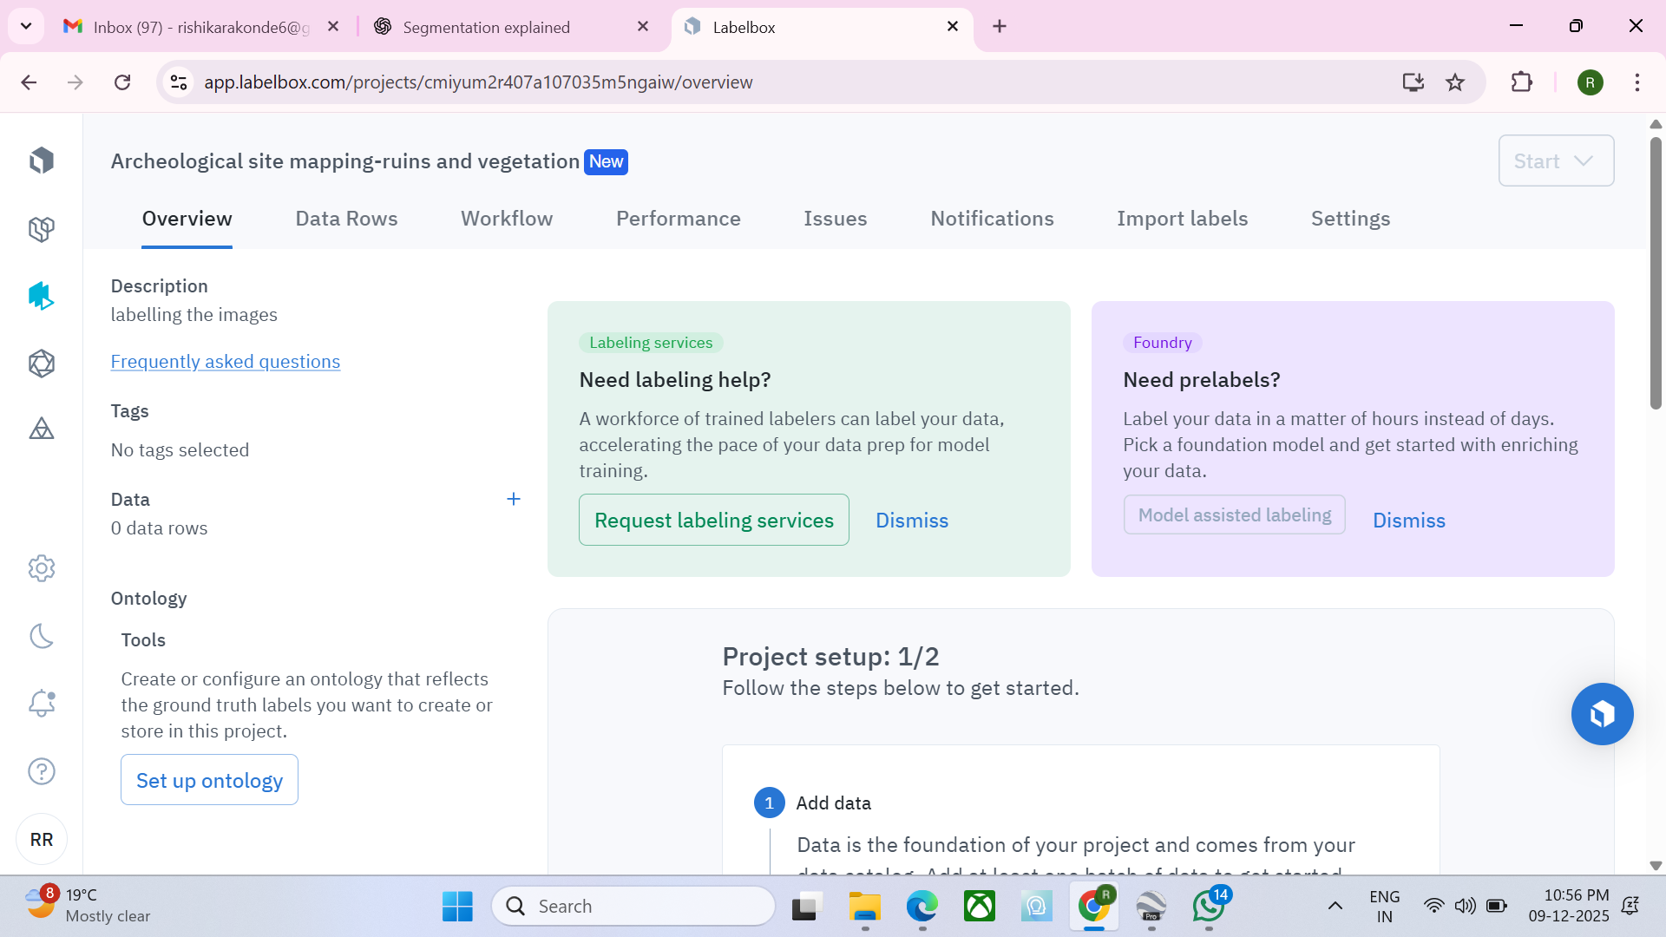

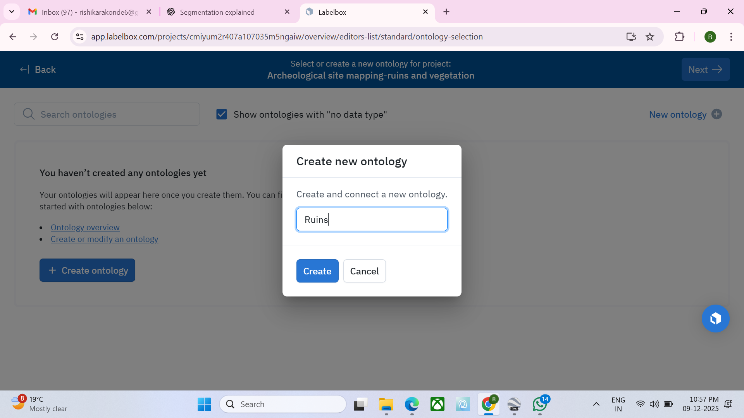

## Week 2 day 3

**Annotating the images:**

* Login to the Labelbox
* Create project by giving a name
* Create classes which are names as ruins and vegetation
* Give a particular shape to each one
* Download the images from google Earth
* In labelbox create dataset and upload the downloaded images
* Now attach the project with the dataset.
* And start labeling.

